Name: Saif Alam

Roll: 61, CSBS

Practical 2 ITW

**Aim:** Write a MATLAB Program to find the greatest of 3 number and program to write a calculator using Switch Case.

**Program:**

Program for Calculator:

a = 10;

b = 2;

calc = 'Add'

switch(calc)

case 'Add'

disp(a+b);

case 'Mul'

disp(a*b);

case 'Div'

disp(a/b);

case 'Sub'

disp(a-b);

otherwise

fprintf("Wrong Selection");

end

Program to Find the greatest out of three numbers:

**Output:** 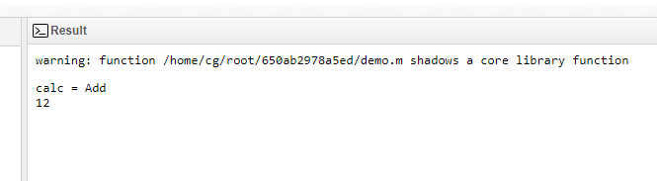

**Program:**

a = 3;

b = 2;

c = 420;

if a>b && a>c

fprintf("a is greatest");

elseif b>c && b>a

fprintf("b is greatest");

else

fprintf("C is greatest");

end

**Output:**

